Джудит Херрин
Византия. Удивительная жизнь средневековой империи
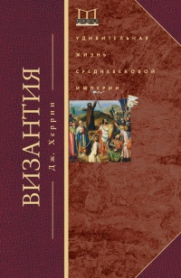
Приложения
Список императоров, упомянутых в тексте
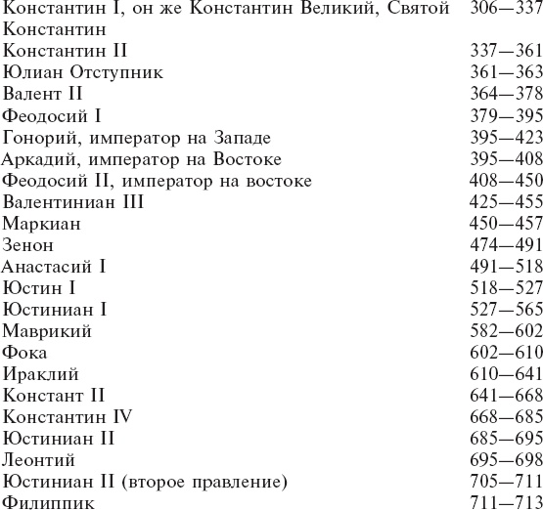

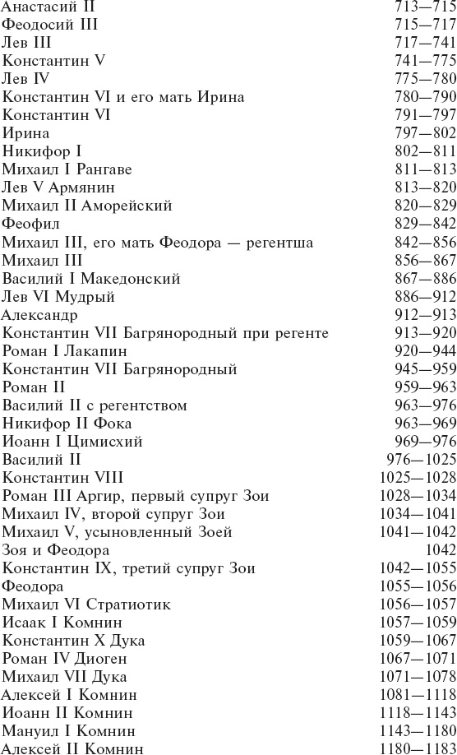
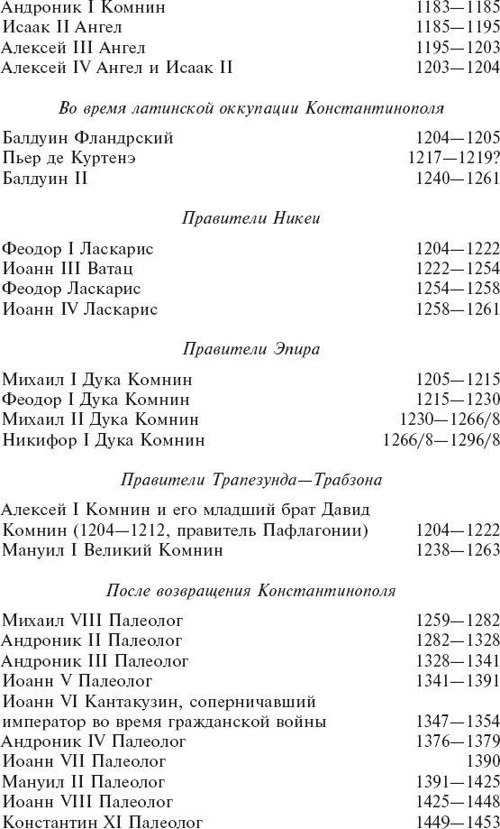
Хронологическая таблица
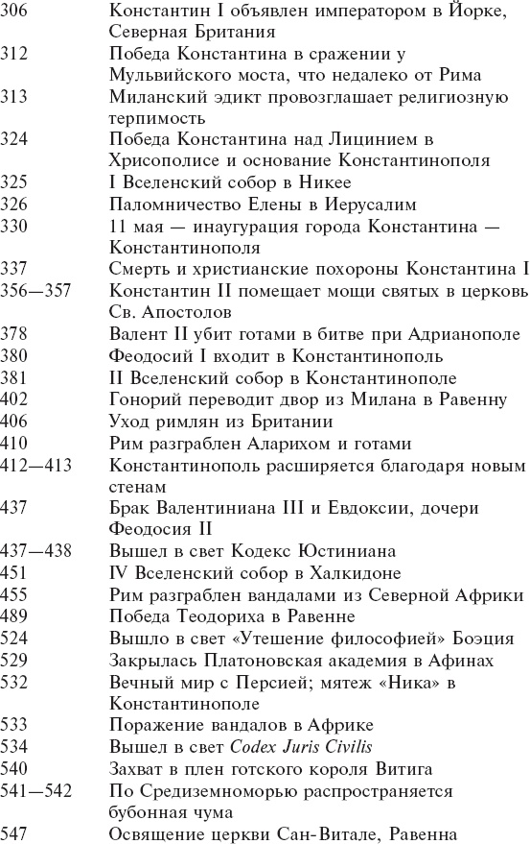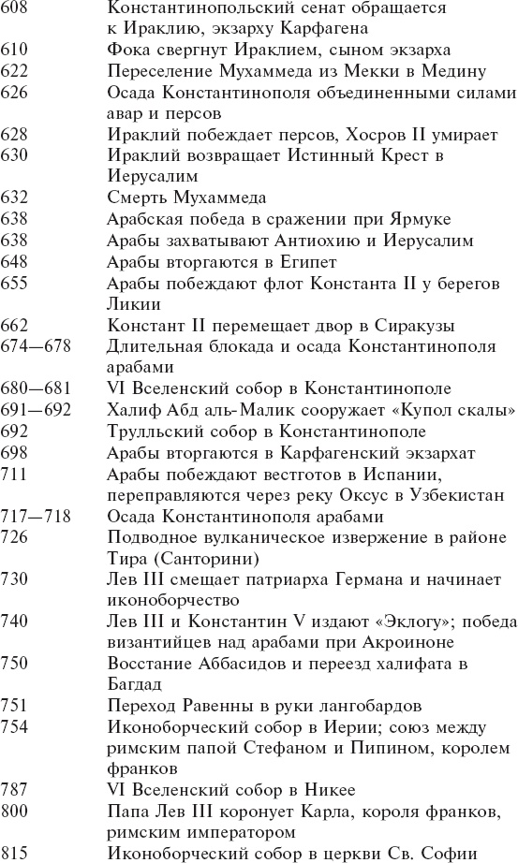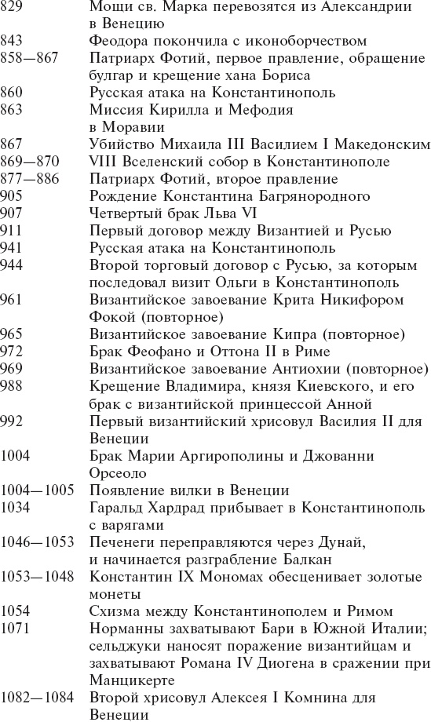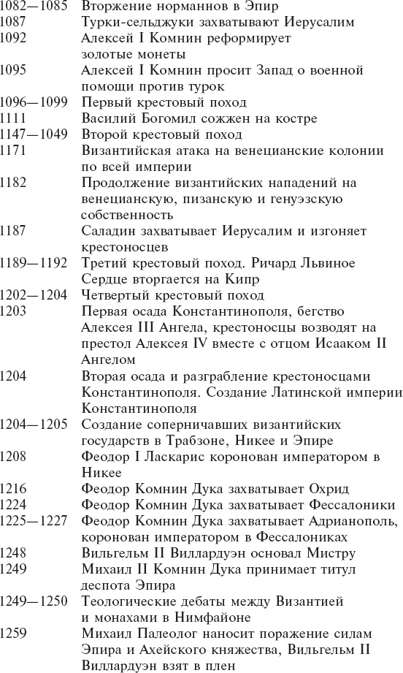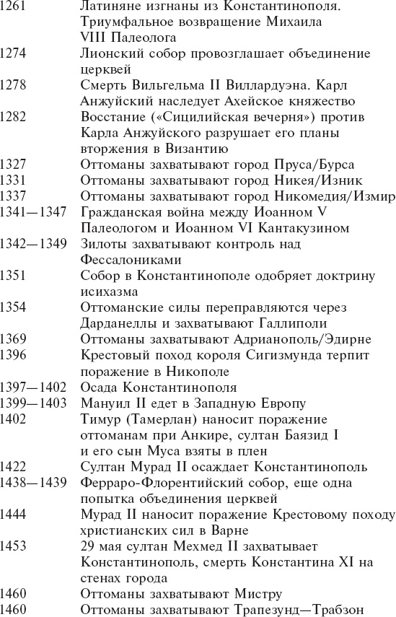
Карты
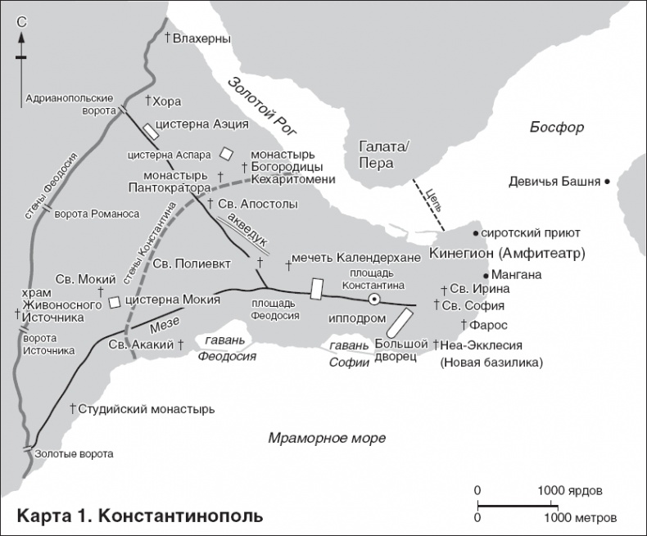
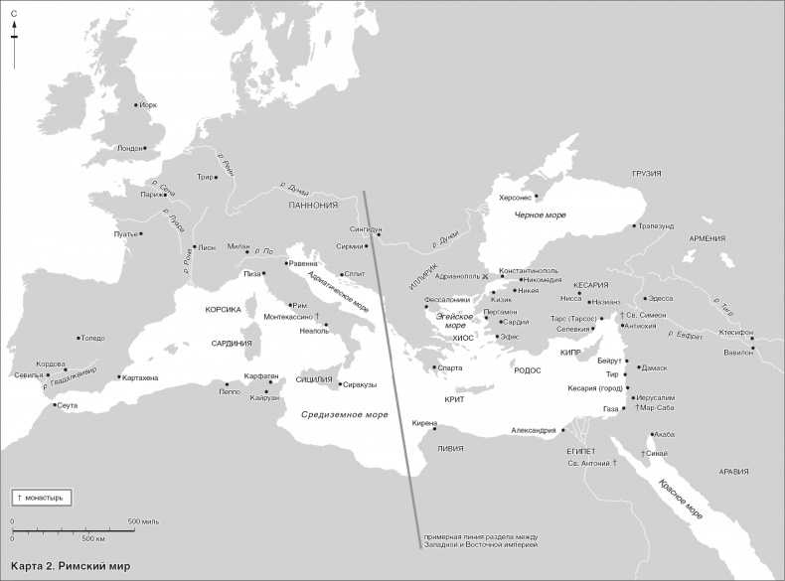

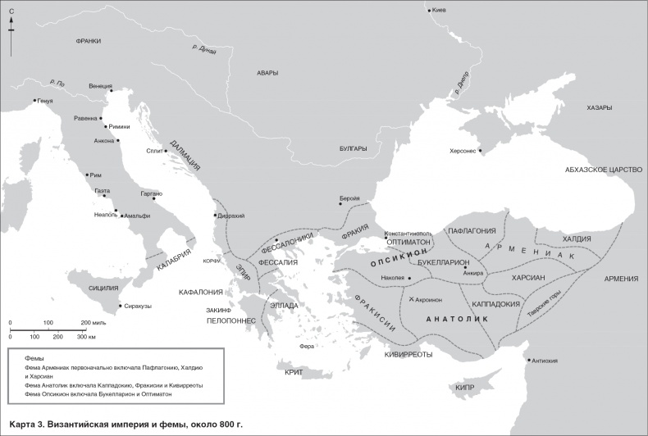

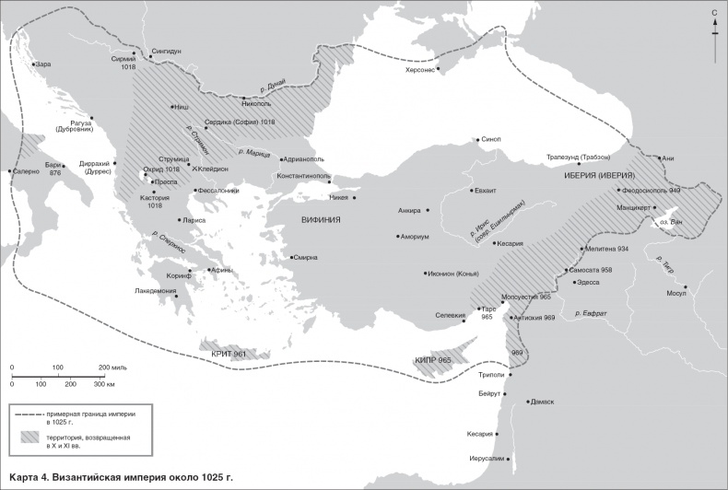

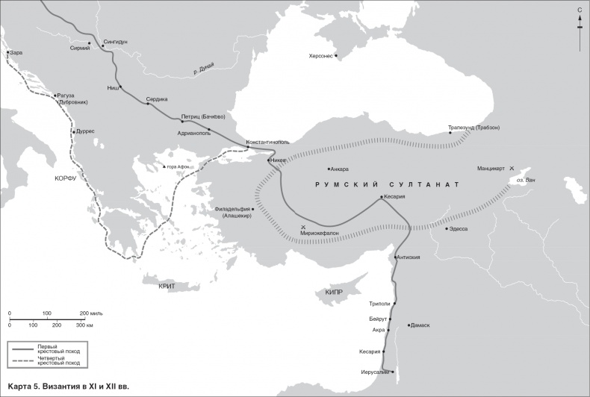
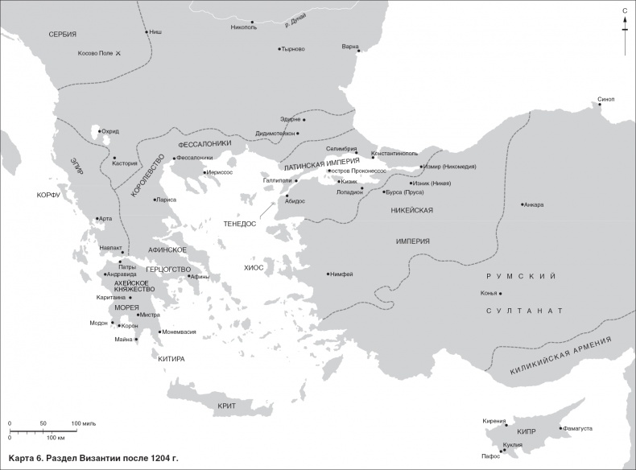

http://loveread.ec/view_global.php?id=69571

INCLUDEPICTURE "http://t0.gstatic.com/images?q=tbn:ANd9GcTDT1jpfS6n_Y4NmsXFnf0dV2uAk854tEHeOSaIXPxUCt7qxHu5xaSaZA" \* MERGEFORMATINET INCLUDEPICTURE "http://t0.gstatic.com/images?q=tbn:ANd9GcTDT1jpfS6n_Y4NmsXFnf0dV2uAk854tEHeOSaIXPxUCt7qxHu5xaSaZA" \* MERGEFORMATINET INCLUDEPICTURE "http://t0.gstatic.com/images?q=tbn:ANd9GcTDT1jpfS6n_Y4NmsXFnf0dV2uAk854tEHeOSaIXPxUCt7qxHu5xaSaZA" \* MERGEFORMATINET INCLUDEPICTURE "http://t0.gstatic.com/images?q=tbn:ANd9GcTDT1jpfS6n_Y4NmsXFnf0dV2uAk854tEHeOSaIXPxUCt7qxHu5xaSaZA" \* MERGEFORMATINET INCLUDEPICTURE "http://t0.gstatic.com/images?q=tbn:ANd9GcTDT1jpfS6n_Y4NmsXFnf0dV2uAk854tEHeOSaIXPxUCt7qxHu5xaSaZA" \* MERGEFORMATINET INCLUDEPICTURE "http://t0.gstatic.com/images?q=tbn:ANd9GcTDT1jpfS6n_Y4NmsXFnf0dV2uAk854tEHeOSaIXPxUCt7qxHu5xaSaZA" \* MERGEFORMATINET INCLUDEPICTURE "http://t0.gstatic.com/images?q=tbn:ANd9GcTDT1jpfS6n_Y4NmsXFnf0dV2uAk854tEHeOSaIXPxUCt7qxHu5xaSaZA" \* MERGEFORMATINET INCLUDEPICTURE "http://t0.gstatic.com/images?q=tbn:ANd9GcTDT1jpfS6n_Y4NmsXFnf0dV2uAk854tEHeOSaIXPxUCt7qxHu5xaSaZA" \* MERGEFORMATINET INCLUDEPICTURE "http://t0.gstatic.com/images?q=tbn:ANd9GcTDT1jpfS6n_Y4NmsXFnf0dV2uAk854tEHeOSaIXPxUCt7qxHu5xaSaZA" \* MERGEFORMATINET INCLUDEPICTURE "http://t0.gstatic.com/images?q=tbn:ANd9GcTDT1jpfS6n_Y4NmsXFnf0dV2uAk854tEHeOSaIXPxUCt7qxHu5xaSaZA" \* MERGEFORMATINET INCLUDEPICTURE "http://t0.gstatic.com/images?q=tbn:ANd9GcTDT1jpfS6n_Y4NmsXFnf0dV2uAk854tEHeOSaIXPxUCt7qxHu5xaSaZA" \* MERGEFORMATINET INCLUDEPICTURE "http://t0.gstatic.com/images?q=tbn:ANd9GcTDT1jpfS6n_Y4NmsXFnf0dV2uAk854tEHeOSaIXPxUCt7qxHu5xaSaZA" \* MERGEFORMATINET INCLUDEPICTURE "http://t0.gstatic.com/images?q=tbn:ANd9GcTDT1jpfS6n_Y4NmsXFnf0dV2uAk854tEHeOSaIXPxUCt7qxHu5xaSaZA" \* MERGEFORMATINET INCLUDEPICTURE "http://t0.gstatic.com/images?q=tbn:ANd9GcTDT1jpfS6n_Y4NmsXFnf0dV2uAk854tEHeOSaIXPxUCt7qxHu5xaSaZA" \* MERGEFORMATINET INCLUDEPICTURE "http://t0.gstatic.com/images?q=tbn:ANd9GcTDT1jpfS6n_Y4NmsXFnf0dV2uAk854tEHeOSaIXPxUCt7qxHu5xaSaZA" \* MERGEFORMATINET INCLUDEPICTURE "http://t0.gstatic.com/images?q=tbn:ANd9GcTDT1jpfS6n_Y4NmsXFnf0dV2uAk854tEHeOSaIXPxUCt7qxHu5xaSaZA" \* MERGEFORMATINET INCLUDEPICTURE "http://t0.gstatic.com/images?q=tbn:ANd9GcTDT1jpfS6n_Y4NmsXFnf0dV2uAk854tEHeOSaIXPxUCt7qxHu5xaSaZA" \* MERGEFORMATINET INCLUDEPICTURE "http://t0.gstatic.com/images?q=tbn:ANd9GcTDT1jpfS6n_Y4NmsXFnf0dV2uAk854tEHeOSaIXPxUCt7qxHu5xaSaZA" \* MERGEFORMATINET INCLUDEPICTURE "http://t0.gstatic.com/images?q=tbn:ANd9GcTDT1jpfS6n_Y4NmsXFnf0dV2uAk854tEHeOSaIXPxUCt7qxHu5xaSaZA" \* MERGEFORMATINET INCLUDEPICTURE "http://t0.gstatic.com/images?q=tbn:ANd9GcTDT1jpfS6n_Y4NmsXFnf0dV2uAk854tEHeOSaIXPxUCt7qxHu5xaSaZA" \* MERGEFORMATINET INCLUDEPICTURE "http://t0.gstatic.com/images?q=tbn:ANd9GcTDT1jpfS6n_Y4NmsXFnf0dV2uAk854tEHeOSaIXPxUCt7qxHu5xaSaZA" \* MERGEFORMATINET INCLUDEPICTURE "http://t0.gstatic.com/images?q=tbn:ANd9GcTDT1jpfS6n_Y4NmsXFnf0dV2uAk854tEHeOSaIXPxUCt7qxHu5xaSaZA" \* MERGEFORMATINET INCLUDEPICTURE "http://t0.gstatic.com/images?q=tbn:ANd9GcTDT1jpfS6n_Y4NmsXFnf0dV2uAk854tEHeOSaIXPxUCt7qxHu5xaSaZA" \* MERGEFORMATINET INCLUDEPICTURE "http://t0.gstatic.com/images?q=tbn:ANd9GcTDT1jpfS6n_Y4NmsXFnf0dV2uAk854tEHeOSaIXPxUCt7qxHu5xaSaZA" \* MERGEFORMATINET INCLUDEPICTURE "http://t0.gstatic.com/images?q=tbn:ANd9GcTDT1jpfS6n_Y4NmsXFnf0dV2uAk854tEHeOSaIXPxUCt7qxHu5xaSaZA" \* MERGEFORMATINET INCLUDEPICTURE "http://t0.gstatic.com/images?q=tbn:ANd9GcTDT1jpfS6n_Y4NmsXFnf0dV2uAk854tEHeOSaIXPxUCt7qxHu5xaSaZA" \* MERGEFORMATINET INCLUDEPICTURE "http://t0.gstatic.com/images?q=tbn:ANd9GcTDT1jpfS6n_Y4NmsXFnf0dV2uAk854tEHeOSaIXPxUCt7qxHu5xaSaZA" \* MERGEFORMATINET INCLUDEPICTURE "http://t0.gstatic.com/images?q=tbn:ANd9GcTDT1jpfS6n_Y4NmsXFnf0dV2uAk854tEHeOSaIXPxUCt7qxHu5xaSaZA" \* MERGEFORMATINET INCLUDEPICTURE "http://t0.gstatic.com/images?q=tbn:ANd9GcTDT1jpfS6n_Y4NmsXFnf0dV2uAk854tEHeOSaIXPxUCt7qxHu5xaSaZA" \* MERGEFORMATINET INCLUDEPICTURE "http://t0.gstatic.com/images?q=tbn:ANd9GcTDT1jpfS6n_Y4NmsXFnf0dV2uAk854tEHeOSaIXPxUCt7qxHu5xaSaZA" \* MERGEFORMATINET INCLUDEPICTURE "http://t0.gstatic.com/images?q=tbn:ANd9GcTDT1jpfS6n_Y4NmsXFnf0dV2uAk854tEHeOSaIXPxUCt7qxHu5xaSaZA" \* MERGEFORMATINET INCLUDEPICTURE "http://t0.gstatic.com/images?q=tbn:ANd9GcTDT1jpfS6n_Y4NmsXFnf0dV2uAk854tEHeOSaIXPxUCt7qxHu5xaSaZA" \* MERGEFORMATINET INCLUDEPICTURE "http://t0.gstatic.com/images?q=tbn:ANd9GcTDT1jpfS6n_Y4NmsXFnf0dV2uAk854tEHeOSaIXPxUCt7qxHu5xaSaZA" \* MERGEFORMATINET INCLUDEPICTURE "http://t0.gstatic.com/images?q=tbn:ANd9GcTDT1jpfS6n_Y4NmsXFnf0dV2uAk854tEHeOSaIXPxUCt7qxHu5xaSaZA" \* MERGEFORMATINET INCLUDEPICTURE "http://t0.gstatic.com/images?q=tbn:ANd9GcTDT1jpfS6n_Y4NmsXFnf0dV2uAk854tEHeOSaIXPxUCt7qxHu5xaSaZA" \* MERGEFORMATINET INCLUDEPICTURE "http://t0.gstatic.com/images?q=tbn:ANd9GcTDT1jpfS6n_Y4NmsXFnf0dV2uAk854tEHeOSaIXPxUCt7qxHu5xaSaZA" \* MERGEFORMATINET INCLUDEPICTURE "http://t0.gstatic.com/images?q=tbn:ANd9GcTDT1jpfS6n_Y4NmsXFnf0dV2uAk854tEHeOSaIXPxUCt7qxHu5xaSaZA" \* MERGEFORMATINET INCLUDEPICTURE "http://t0.gstatic.com/images?q=tbn:ANd9GcTDT1jpfS6n_Y4NmsXFnf0dV2uAk854tEHeOSaIXPxUCt7qxHu5xaSaZA" \* MERGEFORMATINET INCLUDEPICTURE "http://t0.gstatic.com/images?q=tbn:ANd9GcTDT1jpfS6n_Y4NmsXFnf0dV2uAk854tEHeOSaIXPxUCt7qxHu5xaSaZA" \* MERGEFORMATINET INCLUDEPICTURE "http://t0.gstatic.com/images?q=tbn:ANd9GcTDT1jpfS6n_Y4NmsXFnf0dV2uAk854tEHeOSaIXPxUCt7qxHu5xaSaZA" \* MERGEFORMATINET INCLUDEPICTURE "http://t0.gstatic.com/images?q=tbn:ANd9GcTDT1jpfS6n_Y4NmsXFnf0dV2uAk854tEHeOSaIXPxUCt7qxHu5xaSaZA" \* MERGEFORMATINET INCLUDEPICTURE "http://t0.gstatic.com/images?q=tbn:ANd9GcTDT1jpfS6n_Y4NmsXFnf0dV2uAk854tEHeOSaIXPxUCt7qxHu5xaSaZA" \* MERGEFORMATINET INCLUDEPICTURE "http://t0.gstatic.com/images?q=tbn:ANd9GcTDT1jpfS6n_Y4NmsXFnf0dV2uAk854tEHeOSaIXPxUCt7qxHu5xaSaZA" \* MERGEFORMATINET INCLUDEPICTURE "http://t0.gstatic.com/images?q=tbn:ANd9GcTDT1jpfS6n_Y4NmsXFnf0dV2uAk854tEHeOSaIXPxUCt7qxHu5xaSaZA" \* MERGEFORMATINET INCLUDEPICTURE "http://t0.gstatic.com/images?q=tbn:ANd9GcTDT1jpfS6n_Y4NmsXFnf0dV2uAk854tEHeOSaIXPxUCt7qxHu5xaSaZA" \* MERGEFORMATINET INCLUDEPICTURE "http://t0.gstatic.com/images?q=tbn:ANd9GcTDT1jpfS6n_Y4NmsXFnf0dV2uAk854tEHeOSaIXPxUCt7qxHu5xaSaZA" \* MERGEFORMATINET INCLUDEPICTURE "http://t0.gstatic.com/images?q=tbn:ANd9GcTDT1jpfS6n_Y4NmsXFnf0dV2uAk854tEHeOSaIXPxUCt7qxHu5xaSaZA" \* MERGEFORMATINET INCLUDEPICTURE "http://t0.gstatic.com/images?q=tbn:ANd9GcTDT1jpfS6n_Y4NmsXFnf0dV2uAk854tEHeOSaIXPxUCt7qxHu5xaSaZA" \* MERGEFORMATINET INCLUDEPICTURE "http://t0.gstatic.com/images?q=tbn:ANd9GcTDT1jpfS6n_Y4NmsXFnf0dV2uAk854tEHeOSaIXPxUCt7qxHu5xaSaZA" \* MERGEFORMATINET INCLUDEPICTURE "http://t0.gstatic.com/images?q=tbn:ANd9GcTDT1jpfS6n_Y4NmsXFnf0dV2uAk854tEHeOSaIXPxUCt7qxHu5xaSaZA" \* MERGEFORMATINET INCLUDEPICTURE "http://t0.gstatic.com/images?q=tbn:ANd9GcTDT1jpfS6n_Y4NmsXFnf0dV2uAk854tEHeOSaIXPxUCt7qxHu5xaSaZA" \* MERGEFORMATINET INCLUDEPICTURE "http://t0.gstatic.com/images?q=tbn:ANd9GcTDT1jpfS6n_Y4NmsXFnf0dV2uAk854tEHeOSaIXPxUCt7qxHu5xaSaZA" \* MERGEFORMATINET INCLUDEPICTURE "http://t0.gstatic.com/images?q=tbn:ANd9GcTDT1jpfS6n_Y4NmsXFnf0dV2uAk854tEHeOSaIXPxUCt7qxHu5xaSaZA" \* MERGEFORMATINET INCLUDEPICTURE "http://t0.gstatic.com/images?q=tbn:ANd9GcTDT1jpfS6n_Y4NmsXFnf0dV2uAk854tEHeOSaIXPxUCt7qxHu5xaSaZA" \* MERGEFORMATINET INCLUDEPICTURE "http://t0.gstatic.com/images?q=tbn:ANd9GcTDT1jpfS6n_Y4NmsXFnf0dV2uAk854tEHeOSaIXPxUCt7qxHu5xaSaZA" \* MERGEFORMATINET INCLUDEPICTURE "http://t0.gstatic.com/images?q=tbn:ANd9GcTDT1jpfS6n_Y4NmsXFnf0dV2uAk854tEHeOSaIXPxUCt7qxHu5xaSaZA" \* MERGEFORMATINET INCLUDEPICTURE "http://t0.gstatic.com/images?q=tbn:ANd9GcTDT1jpfS6n_Y4NmsXFnf0dV2uAk854tEHeOSaIXPxUCt7qxHu5xaSaZA" \* MERGEFORMATINET INCLUDEPICTURE "http://t0.gstatic.com/images?q=tbn:ANd9GcTDT1jpfS6n_Y4NmsXFnf0dV2uAk854tEHeOSaIXPxUCt7qxHu5xaSaZA" \* MERGEFORMATINET INCLUDEPICTURE "http://t0.gstatic.com/images?q=tbn:ANd9GcTDT1jpfS6n_Y4NmsXFnf0dV2uAk854tEHeOSaIXPxUCt7qxHu5xaSaZA" \* MERGEFORMATINET INCLUDEPICTURE "http://t0.gstatic.com/images?q=tbn:ANd9GcTDT1jpfS6n_Y4NmsXFnf0dV2uAk854tEHeOSaIXPxUCt7qxHu5xaSaZA" \* MERGEFORMATINET INCLUDEPICTURE "http://t0.gstatic.com/images?q=tbn:ANd9GcTDT1jpfS6n_Y4NmsXFnf0dV2uAk854tEHeOSaIXPxUCt7qxHu5xaSaZA" \* MERGEFORMATINET INCLUDEPICTURE "http://t0.gstatic.com/images?q=tbn:ANd9GcTDT1jpfS6n_Y4NmsXFnf0dV2uAk854tEHeOSaIXPxUCt7qxHu5xaSaZA" \* MERGEFORMATINET INCLUDEPICTURE "http://t0.gstatic.com/images?q=tbn:ANd9GcTDT1jpfS6n_Y4NmsXFnf0dV2uAk854tEHeOSaIXPxUCt7qxHu5xaSaZA" \* MERGEFORMATINET INCLUDEPICTURE "http://t0.gstatic.com/images?q=tbn:ANd9GcTDT1jpfS6n_Y4NmsXFnf0dV2uAk854tEHeOSaIXPxUCt7qxHu5xaSaZA" \* MERGEFORMATINET INCLUDEPICTURE "http://t0.gstatic.com/images?q=tbn:ANd9GcTDT1jpfS6n_Y4NmsXFnf0dV2uAk854tEHeOSaIXPxUCt7qxHu5xaSaZA" \* MERGEFORMATINET INCLUDEPICTURE "http://t0.gstatic.com/images?q=tbn:ANd9GcTDT1jpfS6n_Y4NmsXFnf0dV2uAk854tEHeOSaIXPxUCt7qxHu5xaSaZA" \* MERGEFORMATINET INCLUDEPICTURE "http://t0.gstatic.com/images?q=tbn:ANd9GcTDT1jpfS6n_Y4NmsXFnf0dV2uAk854tEHeOSaIXPxUCt7qxHu5xaSaZA" \* MERGEFORMATINET INCLUDEPICTURE "http://t0.gstatic.com/images?q=tbn:ANd9GcTDT1jpfS6n_Y4NmsXFnf0dV2uAk854tEHeOSaIXPxUCt7qxHu5xaSaZA" \* MERGEFORMATINET INCLUDEPICTURE "http://t0.gstatic.com/images?q=tbn:ANd9GcTDT1jpfS6n_Y4NmsXFnf0dV2uAk854tEHeOSaIXPxUCt7qxHu5xaSaZA" \* MERGEFORMATINET INCLUDEPICTURE "http://t0.gstatic.com/images?q=tbn:ANd9GcTDT1jpfS6n_Y4NmsXFnf0dV2uAk854tEHeOSaIXPxUCt7qxHu5xaSaZA" \* MERGEFORMATINET INCLUDEPICTURE "http://t0.gstatic.com/images?q=tbn:ANd9GcTDT1jpfS6n_Y4NmsXFnf0dV2uAk854tEHeOSaIXPxUCt7qxHu5xaSaZA" \* MERGEFORMATINET INCLUDEPICTURE "http://t0.gstatic.com/images?q=tbn:ANd9GcTDT1jpfS6n_Y4NmsXFnf0dV2uAk854tEHeOSaIXPxUCt7qxHu5xaSaZA" \* MERGEFORMATINET INCLUDEPICTURE "http://t0.gstatic.com/images?q=tbn:ANd9GcTDT1jpfS6n_Y4NmsXFnf0dV2uAk854tEHeOSaIXPxUCt7qxHu5xaSaZA" \* MERGEFORMATINET INCLUDEPICTURE "http://t0.gstatic.com/images?q=tbn:ANd9GcTDT1jpfS6n_Y4NmsXFnf0dV2uAk854tEHeOSaIXPxUCt7qxHu5xaSaZA" \* MERGEFORMATINET INCLUDEPICTURE "http://t0.gstatic.com/images?q=tbn:ANd9GcTDT1jpfS6n_Y4NmsXFnf0dV2uAk854tEHeOSaIXPxUCt7qxHu5xaSaZA" \* MERGEFORMATINET INCLUDEPICTURE "http://t0.gstatic.com/images?q=tbn:ANd9GcTDT1jpfS6n_Y4NmsXFnf0dV2uAk854tEHeOSaIXPxUCt7qxHu5xaSaZA" \* MERGEFORMATINET INCLUDEPICTURE "http://t0.gstatic.com/images?q=tbn:ANd9GcTDT1jpfS6n_Y4NmsXFnf0dV2uAk854tEHeOSaIXPxUCt7qxHu5xaSaZA" \* MERGEFORMATINET INCLUDEPICTURE "http://t0.gstatic.com/images?q=tbn:ANd9GcTDT1jpfS6n_Y4NmsXFnf0dV2uAk854tEHeOSaIXPxUCt7qxHu5xaSaZA" \* MERGEFORMATINET INCLUDEPICTURE "http://t0.gstatic.com/images?q=tbn:ANd9GcTDT1jpfS6n_Y4NmsXFnf0dV2uAk854tEHeOSaIXPxUCt7qxHu5xaSaZA" \* MERGEFORMATINET INCLUDEPICTURE "http://t0.gstatic.com/images?q=tbn:ANd9GcTDT1jpfS6n_Y4NmsXFnf0dV2uAk854tEHeOSaIXPxUCt7qxHu5xaSaZA" \* MERGEFORMATINET INCLUDEPICTURE "http://t0.gstatic.com/images?q=tbn:ANd9GcTDT1jpfS6n_Y4NmsXFnf0dV2uAk854tEHeOSaIXPxUCt7qxHu5xaSaZA" \* MERGEFORMATINET INCLUDEPICTURE "http://t0.gstatic.com/images?q=tbn:ANd9GcTDT1jpfS6n_Y4NmsXFnf0dV2uAk854tEHeOSaIXPxUCt7qxHu5xaSaZA" \* MERGEFORMATINET INCLUDEPICTURE "http://t0.gstatic.com/images?q=tbn:ANd9GcTDT1jpfS6n_Y4NmsXFnf0dV2uAk854tEHeOSaIXPxUCt7qxHu5xaSaZA" \* MERGEFORMATINET INCLUDEPICTURE "http://t0.gstatic.com/images?q=tbn:ANd9GcTDT1jpfS6n_Y4NmsXFnf0dV2uAk854tEHeOSaIXPxUCt7qxHu5xaSaZA" \* MERGEFORMATINET INCLUDEPICTURE "http://t0.gstatic.com/images?q=tbn:ANd9GcTDT1jpfS6n_Y4NmsXFnf0dV2uAk854tEHeOSaIXPxUCt7qxHu5xaSaZA" \* MERGEFORMATINET INCLUDEPICTURE "http://t0.gstatic.com/images?q=tbn:ANd9GcTDT1jpfS6n_Y4NmsXFnf0dV2uAk854tEHeOSaIXPxUCt7qxHu5xaSaZA" \* MERGEFORMATINET INCLUDEPICTURE "http://t0.gstatic.com/images?q=tbn:ANd9GcTDT1jpfS6n_Y4NmsXFnf0dV2uAk854tEHeOSaIXPxUCt7qxHu5xaSaZA" \* MERGEFORMATINET INCLUDEPICTURE "http://t0.gstatic.com/images?q=tbn:ANd9GcTDT1jpfS6n_Y4NmsXFnf0dV2uAk854tEHeOSaIXPxUCt7qxHu5xaSaZA" \* MERGEFORMATINET INCLUDEPICTURE "http://t0.gstatic.com/images?q=tbn:ANd9GcTDT1jpfS6n_Y4NmsXFnf0dV2uAk854tEHeOSaIXPxUCt7qxHu5xaSaZA" \* MERGEFORMATINET INCLUDEPICTURE "http://t0.gstatic.com/images?q=tbn:ANd9GcTDT1jpfS6n_Y4NmsXFnf0dV2uAk854tEHeOSaIXPxUCt7qxHu5xaSaZA" \* MERGEFORMATINET INCLUDEPICTURE "http://t0.gstatic.com/images?q=tbn:ANd9GcTDT1jpfS6n_Y4NmsXFnf0dV2uAk854tEHeOSaIXPxUCt7qxHu5xaSaZA" \* MERGEFORMATINET INCLUDEPICTURE "http://t0.gstatic.com/images?q=tbn:ANd9GcTDT1jpfS6n_Y4NmsXFnf0dV2uAk854tEHeOSaIXPxUCt7qxHu5xaSaZA" \* MERGEFORMATINET INCLUDEPICTURE "http://t0.gstatic.com/images?q=tbn:ANd9GcTDT1jpfS6n_Y4NmsXFnf0dV2uAk854tEHeOSaIXPxUCt7qxHu5xaSaZA" \* MERGEFORMATINET INCLUDEPICTURE "http://t0.gstatic.com/images?q=tbn:ANd9GcTDT1jpfS6n_Y4NmsXFnf0dV2uAk854tEHeOSaIXPxUCt7qxHu5xaSaZA" \* MERGEFORMATINET INCLUDEPICTURE "http://t0.gstatic.com/images?q=tbn:ANd9GcTDT1jpfS6n_Y4NmsXFnf0dV2uAk854tEHeOSaIXPxUCt7qxHu5xaSaZA" \* MERGEFORMATINET INCLUDEPICTURE "http://t0.gstatic.com/images?q=tbn:ANd9GcTDT1jpfS6n_Y4NmsXFnf0dV2uAk854tEHeOSaIXPxUCt7qxHu5xaSaZA" \* MERGEFORMATINET INCLUDEPICTURE "http://t0.gstatic.com/images?q=tbn:ANd9GcTDT1jpfS6n_Y4NmsXFnf0dV2uAk854tEHeOSaIXPxUCt7qxHu5xaSaZA" \* MERGEFORMATINET INCLUDEPICTURE "http://t0.gstatic.com/images?q=tbn:ANd9GcTDT1jpfS6n_Y4NmsXFnf0dV2uAk854tEHeOSaIXPxUCt7qxHu5xaSaZA" \* MERGEFORMATINET INCLUDEPICTURE "http://t0.gstatic.com/images?q=tbn:ANd9GcTDT1jpfS6n_Y4NmsXFnf0dV2uAk854tEHeOSaIXPxUCt7qxHu5xaSaZA" \* MERGEFORMATINET INCLUDEPICTURE "http://t0.gstatic.com/images?q=tbn:ANd9GcTDT1jpfS6n_Y4NmsXFnf0dV2uAk854tEHeOSaIXPxUCt7qxHu5xaSaZA" \* MERGEFORMATINET INCLUDEPICTURE "http://t0.gstatic.com/images?q=tbn:ANd9GcTDT1jpfS6n_Y4NmsXFnf0dV2uAk854tEHeOSaIXPxUCt7qxHu5xaSaZA" \* MERGEFORMATINET INCLUDEPICTURE "http://t0.gstatic.com/images?q=tbn:ANd9GcTDT1jpfS6n_Y4NmsXFnf0dV2uAk854tEHeOSaIXPxUCt7qxHu5xaSaZA" \* MERGEFORMATINET INCLUDEPICTURE "http://t0.gstatic.com/images?q=tbn:ANd9GcTDT1jpfS6n_Y4NmsXFnf0dV2uAk854tEHeOSaIXPxUCt7qxHu5xaSaZA" \* MERGEFORMATINET INCLUDEPICTURE "http://t0.gstatic.com/images?q=tbn:ANd9GcTDT1jpfS6n_Y4NmsXFnf0dV2uAk854tEHeOSaIXPxUCt7qxHu5xaSaZA" \* MERGEFORMATINET INCLUDEPICTURE "http://t0.gstatic.com/images?q=tbn:ANd9GcTDT1jpfS6n_Y4NmsXFnf0dV2uAk854tEHeOSaIXPxUCt7qxHu5xaSaZA" \* MERGEFORMATINET INCLUDEPICTURE "http://t0.gstatic.com/images?q=tbn:ANd9GcTDT1jpfS6n_Y4NmsXFnf0dV2uAk854tEHeOSaIXPxUCt7qxHu5xaSaZA" \* MERGEFORMATINET INCLUDEPICTURE "http://t0.gstatic.com/images?q=tbn:ANd9GcTDT1jpfS6n_Y4NmsXFnf0dV2uAk854tEHeOSaIXPxUCt7qxHu5xaSaZA" \* MERGEFORMATINET INCLUDEPICTURE "http://t0.gstatic.com/images?q=tbn:ANd9GcTDT1jpfS6n_Y4NmsXFnf0dV2uAk854tEHeOSaIXPxUCt7qxHu5xaSaZA" \* MERGEFORMATINET INCLUDEPICTURE "http://t0.gstatic.com/images?q=tbn:ANd9GcTDT1jpfS6n_Y4NmsXFnf0dV2uAk854tEHeOSaIXPxUCt7qxHu5xaSaZA" \* MERGEFORMATINET INCLUDEPICTURE "http://t0.gstatic.com/images?q=tbn:ANd9GcTDT1jpfS6n_Y4NmsXFnf0dV2uAk854tEHeOSaIXPxUCt7qxHu5xaSaZA" \* MERGEFORMATINET INCLUDEPICTURE "http://t0.gstatic.com/images?q=tbn:ANd9GcTDT1jpfS6n_Y4NmsXFnf0dV2uAk854tEHeOSaIXPxUCt7qxHu5xaSaZA" \* MERGEFORMATINET INCLUDEPICTURE "http://t0.gstatic.com/images?q=tbn:ANd9GcTDT1jpfS6n_Y4NmsXFnf0dV2uAk854tEHeOSaIXPxUCt7qxHu5xaSaZA" \* MERGEFORMATINET INCLUDEPICTURE "http://t0.gstatic.com/images?q=tbn:ANd9GcTDT1jpfS6n_Y4NmsXFnf0dV2uAk854tEHeOSaIXPxUCt7qxHu5xaSaZA" \* MERGEFORMATINET INCLUDEPICTURE "http://t0.gstatic.com/images?q=tbn:ANd9GcTDT1jpfS6n_Y4NmsXFnf0dV2uAk854tEHeOSaIXPxUCt7qxHu5xaSaZA" \* MERGEFORMATINET INCLUDEPICTURE "http://t0.gstatic.com/images?q=tbn:ANd9GcTDT1jpfS6n_Y4NmsXFnf0dV2uAk854tEHeOSaIXPxUCt7qxHu5xaSaZA" \* MERGEFORMATINET INCLUDEPICTURE "http://t0.gstatic.com/images?q=tbn:ANd9GcTDT1jpfS6n_Y4NmsXFnf0dV2uAk854tEHeOSaIXPxUCt7qxHu5xaSaZA" \* MERGEFORMATINET INCLUDEPICTURE "http://t0.gstatic.com/images?q=tbn:ANd9GcTDT1jpfS6n_Y4NmsXFnf0dV2uAk854tEHeOSaIXPxUCt7qxHu5xaSaZA" \* MERGEFORMATINET INCLUDEPICTURE "http://t0.gstatic.com/images?q=tbn:ANd9GcTDT1jpfS6n_Y4NmsXFnf0dV2uAk854tEHeOSaIXPxUCt7qxHu5xaSaZA" \* MERGEFORMATINET INCLUDEPICTURE "http://t0.gstatic.com/images?q=tbn:ANd9GcTDT1jpfS6n_Y4NmsXFnf0dV2uAk854tEHeOSaIXPxUCt7qxHu5xaSaZA" \* MERGEFORMATINET INCLUDEPICTURE "http://t0.gstatic.com/images?q=tbn:ANd9GcTDT1jpfS6n_Y4NmsXFnf0dV2uAk854tEHeOSaIXPxUCt7qxHu5xaSaZA" \* MERGEFORMATINET INCLUDEPICTURE "http://t0.gstatic.com/images?q=tbn:ANd9GcTDT1jpfS6n_Y4NmsXFnf0dV2uAk854tEHeOSaIXPxUCt7qxHu5xaSaZA" \* MERGEFORMATINET INCLUDEPICTURE "http://t0.gstatic.com/images?q=tbn:ANd9GcTDT1jpfS6n_Y4NmsXFnf0dV2uAk854tEHeOSaIXPxUCt7qxHu5xaSaZA" \* MERGEFORMATINET INCLUDEPICTURE "http://t0.gstatic.com/images?q=tbn:ANd9GcTDT1jpfS6n_Y4NmsXFnf0dV2uAk854tEHeOSaIXPxUCt7qxHu5xaSaZA" \* MERGEFORMATINET INCLUDEPICTURE "http://t0.gstatic.com/images?q=tbn:ANd9GcTDT1jpfS6n_Y4NmsXFnf0dV2uAk854tEHeOSaIXPxUCt7qxHu5xaSaZA" \* MERGEFORMATINET INCLUDEPICTURE "http://t0.gstatic.com/images?q=tbn:ANd9GcTDT1jpfS6n_Y4NmsXFnf0dV2uAk854tEHeOSaIXPxUCt7qxHu5xaSaZA" \* MERGEFORMATINET INCLUDEPICTURE "http://t0.gstatic.com/images?q=tbn:ANd9GcTDT1jpfS6n_Y4NmsXFnf0dV2uAk854tEHeOSaIXPxUCt7qxHu5xaSaZA" \* MERGEFORMATINET INCLUDEPICTURE "http://t0.gstatic.com/images?q=tbn:ANd9GcTDT1jpfS6n_Y4NmsXFnf0dV2uAk854tEHeOSaIXPxUCt7qxHu5xaSaZA" \* MERGEFORMATINET INCLUDEPICTURE "http://t0.gstatic.com/images?q=tbn:ANd9GcTDT1jpfS6n_Y4NmsXFnf0dV2uAk854tEHeOSaIXPxUCt7qxHu5xaSaZA" \* MERGEFORMATINET INCLUDEPICTURE "http://t0.gstatic.com/images?q=tbn:ANd9GcTDT1jpfS6n_Y4NmsXFnf0dV2uAk854tEHeOSaIXPxUCt7qxHu5xaSaZA" \* MERGEFORMATINET INCLUDEPICTURE "http://t0.gstatic.com/images?q=tbn:ANd9GcTDT1jpfS6n_Y4NmsXFnf0dV2uAk854tEHeOSaIXPxUCt7qxHu5xaSaZA" \* MERGEFORMATINET INCLUDEPICTURE "http://t0.gstatic.com/images?q=tbn:ANd9GcTDT1jpfS6n_Y4NmsXFnf0dV2uAk854tEHeOSaIXPxUCt7qxHu5xaSaZA" \* MERGEFORMATINET INCLUDEPICTURE "http://t0.gstatic.com/images?q=tbn:ANd9GcTDT1jpfS6n_Y4NmsXFnf0dV2uAk854tEHeOSaIXPxUCt7qxHu5xaSaZA" \* MERGEFORMATINET INCLUDEPICTURE "http://t0.gstatic.com/images?q=tbn:ANd9GcTDT1jpfS6n_Y4NmsXFnf0dV2uAk854tEHeOSaIXPxUCt7qxHu5xaSaZA" \* MERGEFORMATINET INCLUDEPICTURE "http://t0.gstatic.com/images?q=tbn:ANd9GcTDT1jpfS6n_Y4NmsXFnf0dV2uAk854tEHeOSaIXPxUCt7qxHu5xaSaZA" \* MERGEFORMATINET INCLUDEPICTURE "http://t0.gstatic.com/images?q=tbn:ANd9GcTDT1jpfS6n_Y4NmsXFnf0dV2uAk854tEHeOSaIXPxUCt7qxHu5xaSaZA" \* MERGEFORMATINET INCLUDEPICTURE "http://t0.gstatic.com/images?q=tbn:ANd9GcTDT1jpfS6n_Y4NmsXFnf0dV2uAk854tEHeOSaIXPxUCt7qxHu5xaSaZA" \* MERGEFORMATINET INCLUDEPICTURE "http://t0.gstatic.com/images?q=tbn:ANd9GcTDT1jpfS6n_Y4NmsXFnf0dV2uAk854tEHeOSaIXPxUCt7qxHu5xaSaZA" \* MERGEFORMATINET INCLUDEPICTURE "http://t0.gstatic.com/images?q=tbn:ANd9GcTDT1jpfS6n_Y4NmsXFnf0dV2uAk854tEHeOSaIXPxUCt7qxHu5xaSaZA" \* MERGEFORMATINET INCLUDEPICTURE "http://t0.gstatic.com/images?q=tbn:ANd9GcTDT1jpfS6n_Y4NmsXFnf0dV2uAk854tEHeOSaIXPxUCt7qxHu5xaSaZA" \* MERGEFORMATINET INCLUDEPICTURE "http://t0.gstatic.com/images?q=tbn:ANd9GcTDT1jpfS6n_Y4NmsXFnf0dV2uAk854tEHeOSaIXPxUCt7qxHu5xaSaZA" \* MERGEFORMATINET INCLUDEPICTURE "http://t0.gstatic.com/images?q=tbn:ANd9GcTDT1jpfS6n_Y4NmsXFnf0dV2uAk854tEHeOSaIXPxUCt7qxHu5xaSaZA" \* MERGEFORMATINET INCLUDEPICTURE "http://t0.gstatic.com/images?q=tbn:ANd9GcTDT1jpfS6n_Y4NmsXFnf0dV2uAk854tEHeOSaIXPxUCt7qxHu5xaSaZA" \* MERGEFORMATINET INCLUDEPICTURE "http://t0.gstatic.com/images?q=tbn:ANd9GcTDT1jpfS6n_Y4NmsXFnf0dV2uAk854tEHeOSaIXPxUCt7qxHu5xaSaZA" \* MERGEFORMATINET INCLUDEPICTURE "http://t0.gstatic.com/images?q=tbn:ANd9GcTDT1jpfS6n_Y4NmsXFnf0dV2uAk854tEHeOSaIXPxUCt7qxHu5xaSaZA" \* MERGEFORMATINET INCLUDEPICTURE "http://t0.gstatic.com/images?q=tbn:ANd9GcTDT1jpfS6n_Y4NmsXFnf0dV2uAk854tEHeOSaIXPxUCt7qxHu5xaSaZA" \* MERGEFORMATINET INCLUDEPICTURE "http://t0.gstatic.com/images?q=tbn:ANd9GcTDT1jpfS6n_Y4NmsXFnf0dV2uAk854tEHeOSaIXPxUCt7qxHu5xaSaZA" \* MERGEFORMATINET INCLUDEPICTURE "http://t0.gstatic.com/images?q=tbn:ANd9GcTDT1jpfS6n_Y4NmsXFnf0dV2uAk854tEHeOSaIXPxUCt7qxHu5xaSaZA" \* MERGEFORMATINET INCLUDEPICTURE "http://t0.gstatic.com/images?q=tbn:ANd9GcTDT1jpfS6n_Y4NmsXFnf0dV2uAk854tEHeOSaIXPxUCt7qxHu5xaSaZA" \* MERGEFORMATINET INCLUDEPICTURE "http://t0.gstatic.com/images?q=tbn:ANd9GcTDT1jpfS6n_Y4NmsXFnf0dV2uAk854tEHeOSaIXPxUCt7qxHu5xaSaZA" \* MERGEFORMATINET INCLUDEPICTURE "http://t0.gstatic.com/images?q=tbn:ANd9GcTDT1jpfS6n_Y4NmsXFnf0dV2uAk854tEHeOSaIXPxUCt7qxHu5xaSaZA" \* MERGEFORMATINET INCLUDEPICTURE "http://t0.gstatic.com/images?q=tbn:ANd9GcTDT1jpfS6n_Y4NmsXFnf0dV2uAk854tEHeOSaIXPxUCt7qxHu5xaSaZA" \* MERGEFORMATINET INCLUDEPICTURE "http://t0.gstatic.com/images?q=tbn:ANd9GcTDT1jpfS6n_Y4NmsXFnf0dV2uAk854tEHeOSaIXPxUCt7qxHu5xaSaZA" \* MERGEFORMATINET INCLUDEPICTURE "http://t0.gstatic.com/images?q=tbn:ANd9GcTDT1jpfS6n_Y4NmsXFnf0dV2uAk854tEHeOSaIXPxUCt7qxHu5xaSaZA" \* MERGEFORMATINET INCLUDEPICTURE "http://t0.gstatic.com/images?q=tbn:ANd9GcTDT1jpfS6n_Y4NmsXFnf0dV2uAk854tEHeOSaIXPxUCt7qxHu5xaSaZA" \* MERGEFORMATINET INCLUDEPICTURE "http://t0.gstatic.com/images?q=tbn:ANd9GcTDT1jpfS6n_Y4NmsXFnf0dV2uAk854tEHeOSaIXPxUCt7qxHu5xaSaZA" \* MERGEFORMATINET INCLUDEPICTURE "http://t0.gstatic.com/images?q=tbn:ANd9GcTDT1jpfS6n_Y4NmsXFnf0dV2uAk854tEHeOSaIXPxUCt7qxHu5xaSaZA" \* MERGEFORMATINET INCLUDEPICTURE "http://t0.gstatic.com/images?q=tbn:ANd9GcTDT1jpfS6n_Y4NmsXFnf0dV2uAk854tEHeOSaIXPxUCt7qxHu5xaSaZA" \* MERGEFORMATINET INCLUDEPICTURE "http://t0.gstatic.com/images?q=tbn:ANd9GcTDT1jpfS6n_Y4NmsXFnf0dV2uAk854tEHeOSaIXPxUCt7qxHu5xaSaZA" \* MERGEFORMATINET INCLUDEPICTURE "http://t0.gstatic.com/images?q=tbn:ANd9GcTDT1jpfS6n_Y4NmsXFnf0dV2uAk854tEHeOSaIXPxUCt7qxHu5xaSaZA" \* MERGEFORMATINET INCLUDEPICTURE "http://t0.gstatic.com/images?q=tbn:ANd9GcTDT1jpfS6n_Y4NmsXFnf0dV2uAk854tEHeOSaIXPxUCt7qxHu5xaSaZA" \* MERGEFORMATINET INCLUDEPICTURE "http://t0.gstatic.com/images?q=tbn:ANd9GcTDT1jpfS6n_Y4NmsXFnf0dV2uAk854tEHeOSaIXPxUCt7qxHu5xaSaZA" \* MERGEFORMATINET INCLUDEPICTURE "http://t0.gstatic.com/images?q=tbn:ANd9GcTDT1jpfS6n_Y4NmsXFnf0dV2uAk854tEHeOSaIXPxUCt7qxHu5xaSaZA" \* MERGEFORMATINET INCLUDEPICTURE "http://t0.gstatic.com/images?q=tbn:ANd9GcTDT1jpfS6n_Y4NmsXFnf0dV2uAk854tEHeOSaIXPxUCt7qxHu5xaSaZA" \* MERGEFORMATINET INCLUDEPICTURE "http://t0.gstatic.com/images?q=tbn:ANd9GcTDT1jpfS6n_Y4NmsXFnf0dV2uAk854tEHeOSaIXPxUCt7qxHu5xaSaZA" \* MERGEFORMATINET INCLUDEPICTURE "http://t0.gstatic.com/images?q=tbn:ANd9GcTDT1jpfS6n_Y4NmsXFnf0dV2uAk854tEHeOSaIXPxUCt7qxHu5xaSaZA" \* MERGEFORMATINET INCLUDEPICTURE "http://t0.gstatic.com/images?q=tbn:ANd9GcTDT1jpfS6n_Y4NmsXFnf0dV2uAk854tEHeOSaIXPxUCt7qxHu5xaSaZA" \* MERGEFORMATINET INCLUDEPICTURE "http://t0.gstatic.com/images?q=tbn:ANd9GcTDT1jpfS6n_Y4NmsXFnf0dV2uAk854tEHeOSaIXPxUCt7qxHu5xaSaZA" \* MERGEFORMATINET INCLUDEPICTURE "http://t0.gstatic.com/images?q=tbn:ANd9GcTDT1jpfS6n_Y4NmsXFnf0dV2uAk854tEHeOSaIXPxUCt7qxHu5xaSaZA" \* MERGEFORMATINET INCLUDEPICTURE "http://t0.gstatic.com/images?q=tbn:ANd9GcTDT1jpfS6n_Y4NmsXFnf0dV2uAk854tEHeOSaIXPxUCt7qxHu5xaSaZA" \* MERGEFORMATINET INCLUDEPICTURE "http://t0.gstatic.com/images?q=tbn:ANd9GcTDT1jpfS6n_Y4NmsXFnf0dV2uAk854tEHeOSaIXPxUCt7qxHu5xaSaZA" \* MERGEFORMATINET INCLUDEPICTURE "http://t0.gstatic.com/images?q=tbn:ANd9GcTDT1jpfS6n_Y4NmsXFnf0dV2uAk854tEHeOSaIXPxUCt7qxHu5xaSaZA" \* MERGEFORMATINET INCLUDEPICTURE "http://t0.gstatic.com/images?q=tbn:ANd9GcTDT1jpfS6n_Y4NmsXFnf0dV2uAk854tEHeOSaIXPxUCt7qxHu5xaSaZA" \* MERGEFORMATINET INCLUDEPICTURE "http://t0.gstatic.com/images?q=tbn:ANd9GcTDT1jpfS6n_Y4NmsXFnf0dV2uAk854tEHeOSaIXPxUCt7qxHu5xaSaZA" \* MERGEFORMATINET INCLUDEPICTURE "http://t0.gstatic.com/images?q=tbn:ANd9GcTDT1jpfS6n_Y4NmsXFnf0dV2uAk854tEHeOSaIXPxUCt7qxHu5xaSaZA" \* MERGEFORMATINET

Compiler FLN

